



Name : Hafsa Shahid
Reg no : B25F34CYS101
Program : Cybersecurity
Instructor’s name: Hassan Ali
Date Submitted : 17 / 07 / 26
Deadline : 17 / 07 / 26
Assignment Report # 7

\

• INTRODUCTION •
In this assignment, we explored the concepts of Web Application Security through a few tasks. The objective was to understand how web applications function, and how common security vulnerabilities can be identified and exploited. The assignment consists of three tasks; it goes as follows

Assignments Tasks:

Task #01 : Web Application Reconnaissance & Technology Identification, choose an authorized test website Identify:
- Website URL
- HTTP vs HTTPS
- Request methods used (GET, POST)
- Response status codes (200, 301, 302, 403, 404, 500)
- Technologies used (server, CMS, framework) using tools like WhatWeb or Wappalyzer.
- Capture screenshots of your findings.
- Write a short report (1–2 pages) explaining your observations.

Task #02 : HTTP Requests, Authentication & Authorization Analysis, Open an authorized web application. Use your browser's Developer Tools to inspect requests. Identify:
- HTTP request headers
- HTTP response headers
- Cookies
- Session ID
- Request methods (GET, POST, PUT, DELETE if present)
- Explain the difference between: Authentication and Authorization
- Tokens (JWT)
- Draw a simple authentication flow diagram.

Task #03 : SQL Injection, Use an intentionally vulnerable application such as http://65.61.137.117/. Review the SQL Injection concept. Perform basic SQL Injection testing on the provided login or search page. Record:
- The vulnerable input field
- Payload(s) used
- Application response
- Why the vulnerability exists
- How parameterized queries (prepared statements) prevent SQL Injection
- Provide screenshots of each step.

• TASK # 01 •
Task #01: Web Application Reconnaissance & Technology Identification, choose an authorized test website.
Identify:
- Website URL
- HTTP vs HTTPS
- Request methods used (GET, POST)
- Response status codes (200, 301, 302, 403, 404, 500)
- Technologies used (server, CMS, framework) using tools like WhatWeb or Wappalyzer.
- Capture screenshots of your findings.
- Write a short report (1–2 pages) explaining your observations.

Website URL :
The URL is found at the top for the OWASP Juice Shop the URL is,
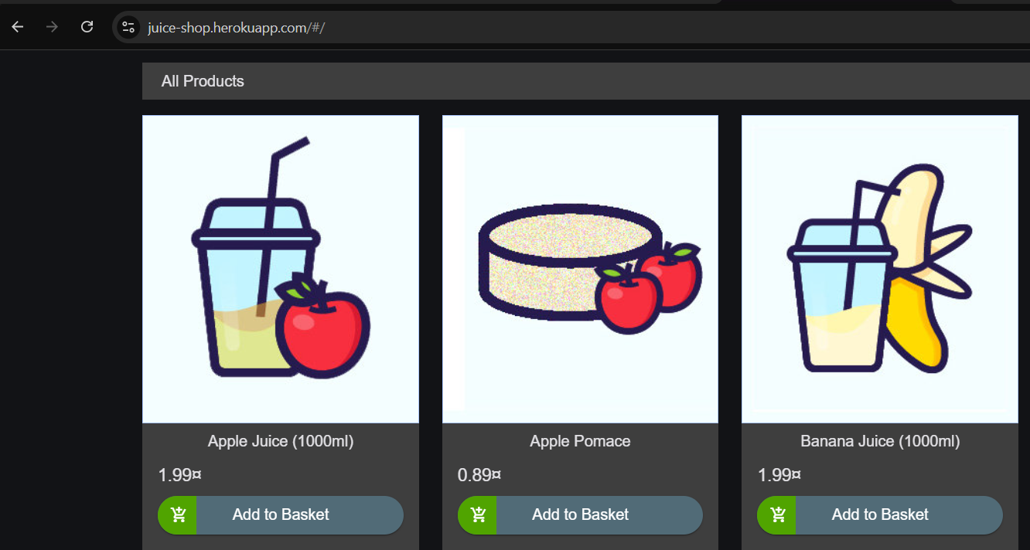
https://juice-shop.herokuapp.com/#/
Task # 01: URL of Website

HTTP vs HTTPs :
The URL found at the top for the OWASP Juice Shop includes HTTPS instead of HTTP. The major difference between these is that in HTTPS, the browser and server first establish a secure connection then exchange data.
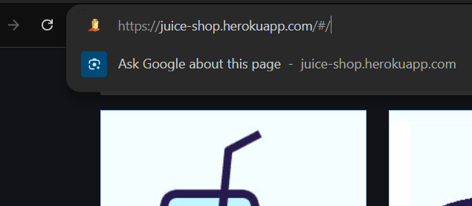

Task # 01: HTTPS used in URL of Website

Request Method :
Request Methods are HTTP commands that tell the server what action to perform. Using Developer Tool. The following request methods have been observed,
- GET: Its purpose retrieve information from server. EXAMPLE, getting an image.
- POST: Its purpose is to send data to server. EXAMPLE, login info.
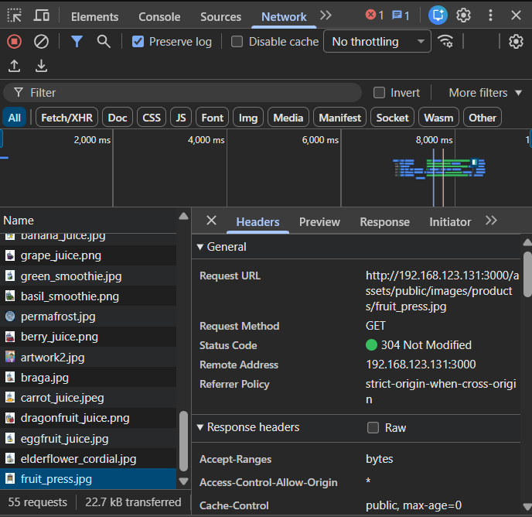

Task # 01: Request Method GET used in Website
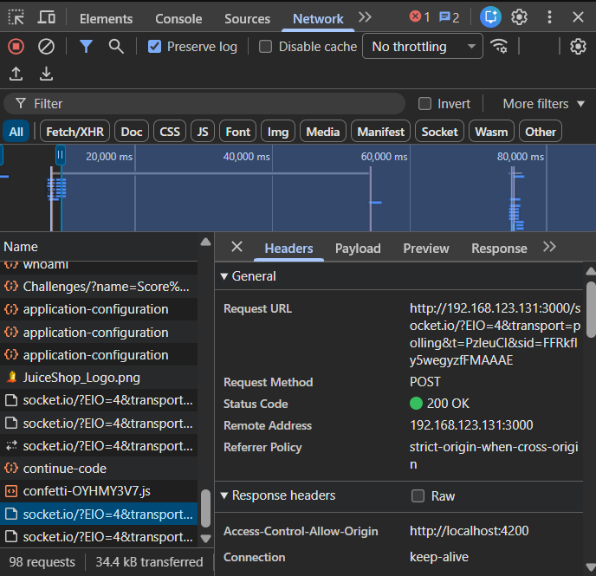

Task # 01: Request Method POST used in Website
Response Status Codes :
HTTP Response Status Codes are three-digit numbers returned by the server to indicate the result of a client’s request. The following response status codes have been observed,
- 200 : Request successful
- 101 : Switching Protocols.
- 304 : Not Modified.
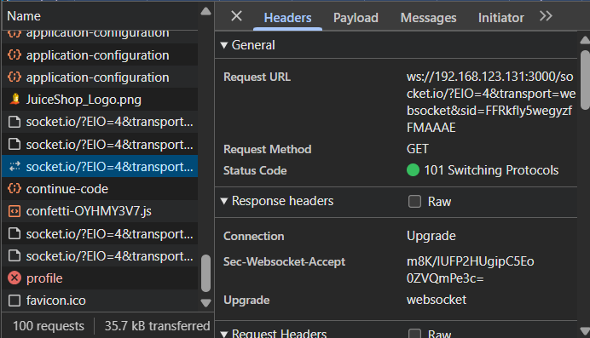
- 500 : Server Error.

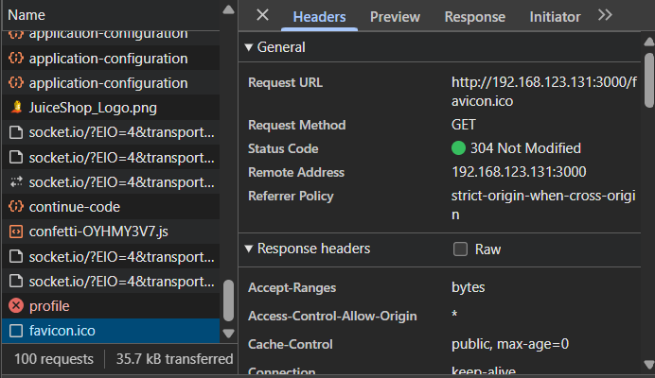
Task # 01: Response Code 101

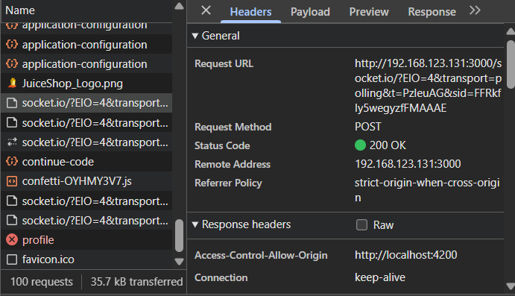
Task # 01: Response Code 304

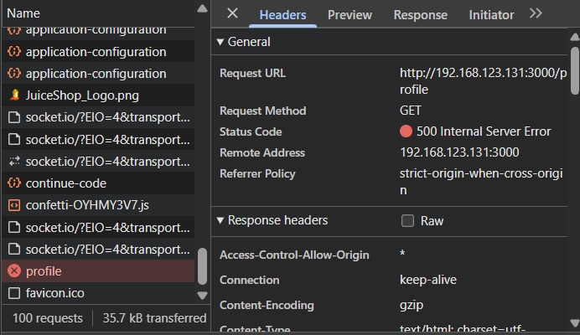
Task # 01: Response Code 200

Task # 01: Response Code 500
Technologies used :
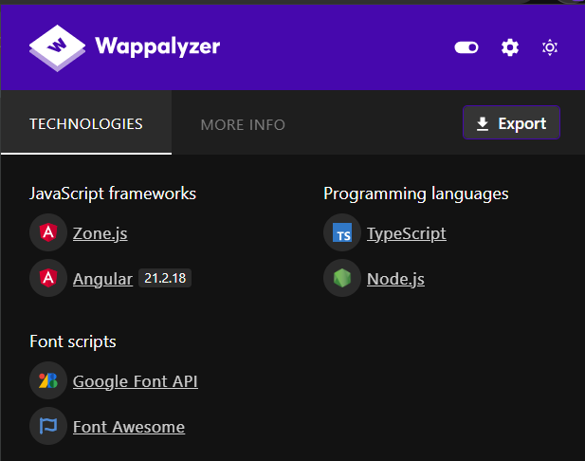
I used Developer Tools and the browser extension Wappalyzer to inspect the website. The website itself uses these tools,

Task # 01: Tools used in Website

Task Conclusion :
In this Task we successfully looked the background of a website Juice Shop. We looked it its,
- URl.
- Request Methods.
- Response Methods.
- The tools the Website uses
We learned how to use developer tools.

• TASK # 02 •
Task #02: HTTP Requests, Authentication & Authorization Analysis, Open an authorized web application. Use your browser's Developer Tools to inspect requests. Identify:
Identify:
- HTTP request headers
- HTTP response headers
- Cookies
- Session ID
- Request methods (GET, POST, PUT, DELETE if present)
- Explain the difference between: Authentication and Authorization
- Tokens (JWT)
- Draw a simple authentication flow diagram.

I am going to inspect the https://www.reddit.com/ Website.

HTTP Request Headers :
HTTP Request Headers are additional information sent by the browser to the server along with each request, such as browser type, cookies, accepted content types, and authorization details. Following is some of the headers I found,
- Method: Get.
- path: /echo.
- Scheme : https.
- Cookie : a long string…
- Authority : reqbin.com.
- Chache-Control : max-age=0.
- Priority : u=0,i

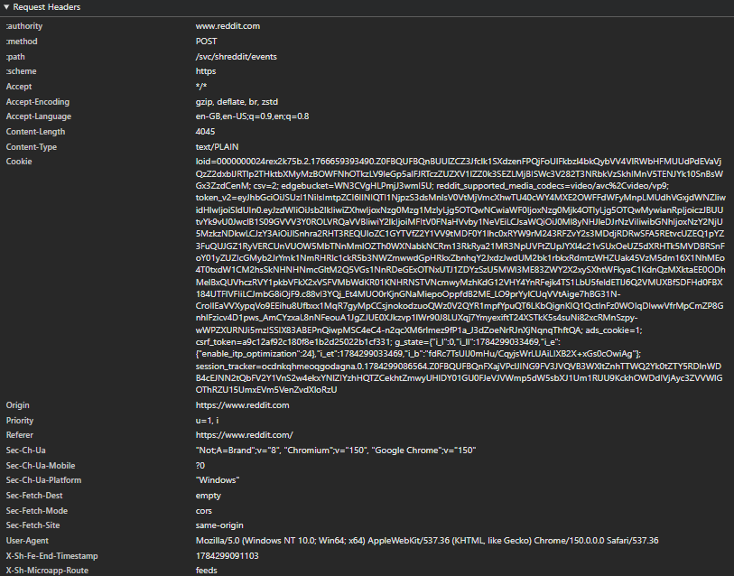

Task # 02: HTTP Request Header

HTTP Response Headers :
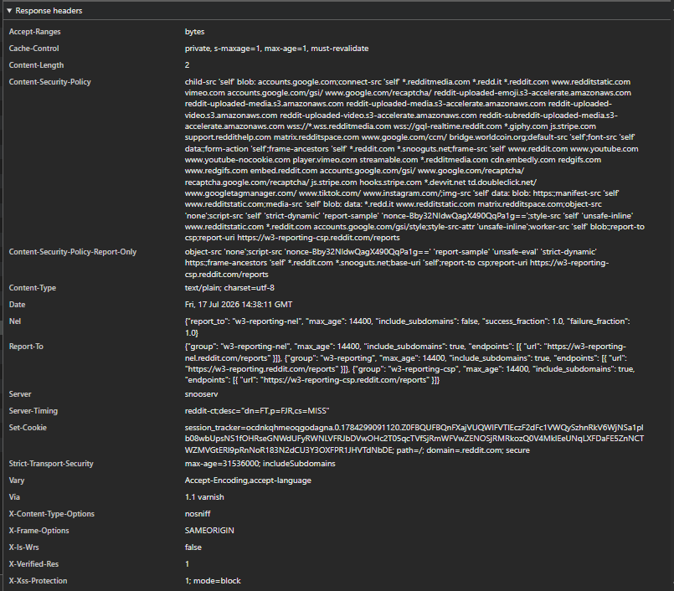
HTTP Response Headers are pieces of information sent by the server back to the browser along with the response, such as status code, content type, server type, and caching instructions. Following is some of the headers I found,

Task # 02: HTTP Response Header
Cookies :
Cookies are small pieces of data stored by the browser and sent back to the server with every request to maintain user sessions, preferences, and authentication. Following are the Cookies I found,
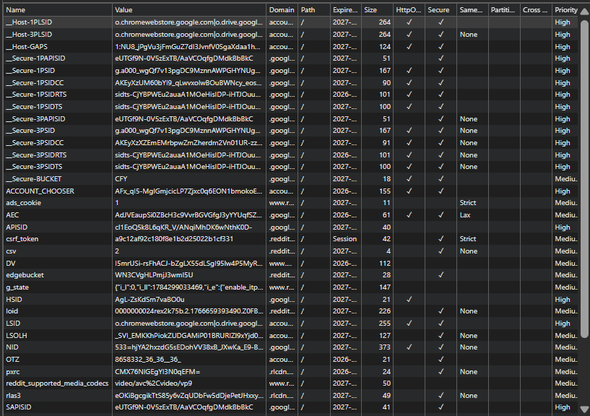

Session ID :
A Session ID is a unique identifier generated by the server and stored in a cookie to track and maintain a user's active session across multiple requests. Following is the Session ID highlighted,
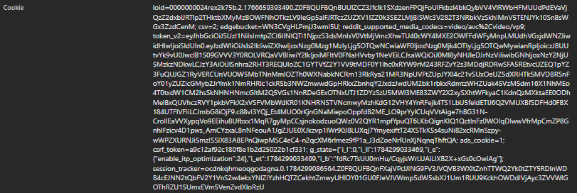

Task # 02: Session ID
Request Method :
Request Methods are HTTP commands that tell the server what action to perform. Using Developer Tool, Following Request Methods have been observed,
- GET: Its purpose retrieve information from server. EXAMPLE, getting an image.
- POST: Its purpose is to send data to server. EXAMPLE, login info.
- OPTIONS : Requests the permitted communication options.

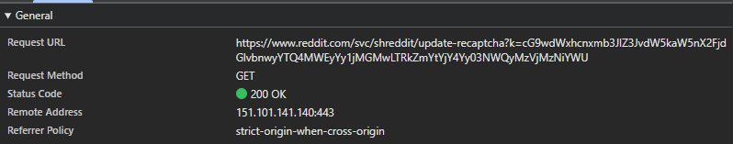

Task # 02: Request Method GET

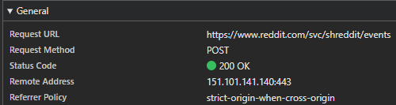

Task # 02: Request Method POST

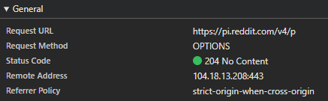

Task # 02: Request Method OPTIONS
Authentication VS Authorization :
Following table describes the difference between Authentication and Authorization,
Point | Authentication | Authorization
Definition | Verifies who the user is | Determines what the user can do
Process | Checks username, password, or biometrics | Checks permissions and access rights
When it Happens | At Login. | After successful authentication
Example | User logs in with email and password | User can view profile but cannot delete users (only admin can)
Task # 02: Difference Between Authentication and Authorization

Tokens :
A token is data that the server gives to the browser after login to prove the user is authenticated and to access protected resources. Following is the Token highlighted,


Task # 02: HTTP Tokens

Flow Diagram :
The Authentication begins after the user has entered their credentials. The server will check it its correct or not. If it is then it will grant the user a token that will validate them. On the Following page is the Flow Diagram for Authentication,

Authentication Process Flow Diagram
Login Page
Browser Sends Login Request
User

Validate Credentials
Creates Token Session
Server
Success

Failure
Return Token

Error!
Browser Stores Token

Future Request + Token

Server Validates

Access Granted!

Task Conclusion :
In this Task we analysed the requests of a website using devtools and looked at the difference between authentication and authorization.
• TASK # 03 •
Task #03 : SQL Injection, Use an intentionally vulnerable application such as http://65.61.137.117/. Review the SQL Injection concept. Perform basic SQL Injection testing on the provided login or search page. Record:
- The vulnerable input field
- Payload(s) used
- Application response
- Why the vulnerability exists
- How parameterized queries (prepared statements) prevent SQL Injection
- Provide screenshots of each step.

Vulnerable Input Field :
The field on the webpage, which is susceptible to SQL Injection due to lack of input sanitization, Like a search bar or the username section of a login page.
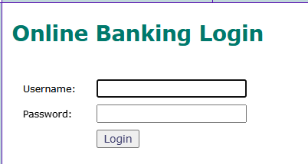

Task # 03: Login Page of Alturo Mutual

Payloads Used :
The Payload is a code that is entered in the Vulnerable Input Field with a value that bypasses the password field. I used the Payloads,
- ‘ OR 1=1--

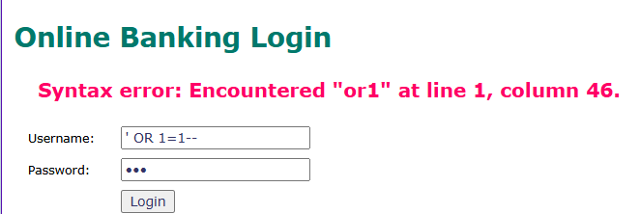

Task # 03: Login Page of Alturo Mutual

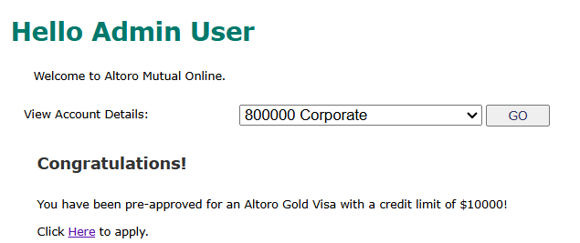

Task # 03: After Login Page of Alturo Mutual

- admin’--

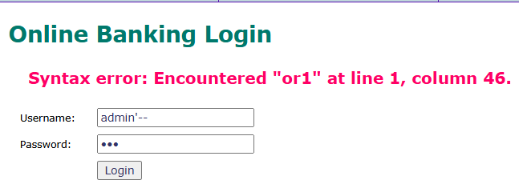

Task # 03: Login Page of Alturo Mutual



Task # 03: After Login Page of Alturo Mutual

Application Response :
When the payload ( ' OR 1=1-- ) or ( admin'--) was entered in the username field and any value was entered in the password field, the login was successful. The application did not validate the credentials and granted access to the after screen. In both cases, I was logged in as the administrator user. After successful bypass, I could view account information and other privileged sections of the application.

Why the Vulnerability Exists :
The vulnerability exists because the website takes whatever you type in the username and directly glues it into the SQL command without checking it first. Instead of treating your input as normal text, the website treats it as part of the actual programming command. So when you type special characters, the website’s command gets broken and changed, allowing you to trick the system into logging you in.
As a result, the application authenticates the user without verifying correct credentials.




Task # 03: Before and After Login Page of Alturo Mutual

Parameterized Queries Prevent SQL Injection :
Parameterized queries solve this problem by separating the SQL code from the user data. Instead of concatenating strings, the query is prepared with placeholders, and the user input is sent separately as parameters. This works because the database engine treats the entire user input as a literal value, not as part of the SQL code, making the injection impossible.

Task Conclusion :
In this Task we learned about SQL injection and parameterized queries and why/how they prevent SQL Injection.

Assignment Conclusion:
In this assignment we Learned about Web Application Reconnaissance and SQL injection to bypass non parameterized queries. This increased and polished my ability to use and learn more about cybersecurity.
• The End •

